**Project Design Phase-II**

**Technology Stack (Architecture & Stack)**

|  |  |
| --- | --- |
| Date | 17 June 2025 |
| Team ID | LTVIP2025TMID58401 |
| Project Name | ShopSmart - eCommerce Grocery Web app |
| Maximum Marks | 4 Marks |

**Technical Architecture:**

The Deliverable shall include the architectural diagram as below and the information as per the table1 & table 2

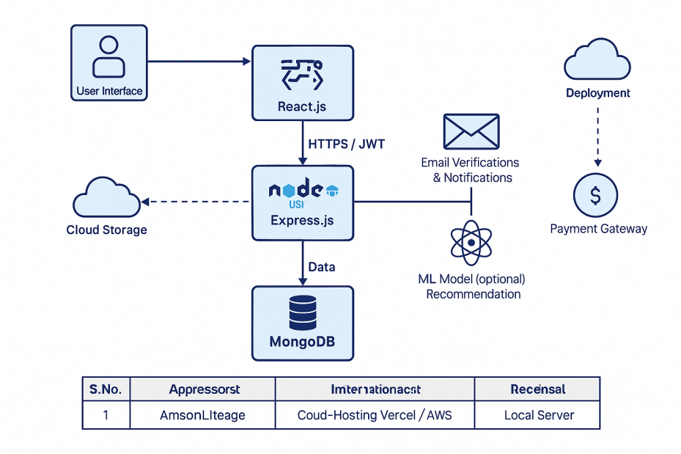

## ****Table-1: Components & Technologies****

| **S.No** | **Component** | **Description** | **Technology** |
| --- | --- | --- | --- |
| 1 | User Interface | Web UI where users interact: browse, login, add to cart etc. | HTML, CSS, JavaScript, React.js |
| 2 | Application Logic-1 | Backend server handling authentication, cart, orders, etc. | Node.js, Express.js |
| 3 | Application Logic-2 | Role-based access control (admin/user) | Middleware in Express.js, JWT authentication |
| 4 | Application Logic-3 | Admin dashboard and product management logic | Node.js, Express.js, React.js |
| 5 | Database | Data storage for users, products, orders, wishlist/cart | MongoDB (NoSQL) |
| 6 | Cloud Database | Managed cloud database | MongoDB Atlas |
| 7 | File Storage | Product images and static assets | Cloud storage like AWS S3 / local filesystem |
| 8 | External API-1 | Payment gateway integration (planned future) | Razorpay / Stripe API |
| 9 | External API-2 | Email service for verification and notifications | Nodemailer / SendGrid API |
| 10 | Machine Learning Model | (Optional / future) product recommendation | Custom ML model hosted separately |
| 11 | Infrastructure (Server / Cloud) | Deployment environment | Local during dev; Vercel / Render / AWS EC2 in production |

## ****Table-2: Application Characteristics****

| **S.No** | **Characteristics** | **Description** | **Technology** |
| --- | --- | --- | --- |
| 1 | Open-Source Frameworks | Using open-source frameworks for frontend and backend | React.js, Node.js, Express.js, MongoDB |
| 2 | Security Implementations | JWT authentication, hashed passwords, HTTPS, validation, OWASP practices | bcrypt, JWT, HTTPS, Helmet.js, CORS |
| 3 | Scalable Architecture | Separated frontend and backend, stateless APIs, scalable NoSQL DB | MERN stack, Docker/Kubernetes for scaling |
| 4 | Availability | Deploy on distributed cloud infrastructure; CDN for assets | Cloud hosting + CDN (e.g., Cloudflare) |
| 5 | Performance | API optimization, lazy loading, caching product images, pagination | Redis (caching, optional), CDN, React lazy loading |

✅ **Highlights:**

**Frontend:** React.js

**Backend:** Node.js + Express.js

**Database:** MongoDB (cloud-hosted with MongoDB Atlas)

**Security:** JWT, bcrypt, Helmet.js

**Deployment:** Netlify

**Planned future:** Payment gateway & ML recommendations